**Republish a message from a workflow**

**Symptom**

A workflow is still running, has not failed, but had a problem with some step in the workflow. That component needs to see the request message again to reprocess it. This is most often the case with VCO.

**Resolution**

Find the message in the Kibana Workflow Messages dashboard, then republish it in the RabbitMQ admin interface.

**Instructions**

To republish a message you'll need access to two GUIs:

1. The Kibana Workflow Messages dashboard (the "WF Logs" link on the wiki's big chart of links)

2. The RabbitMQ admin interface. In environments with more than one RabbitMQ cluster (SYS and PROD), you want the Infrastructure RabbitMQ cluster.

Find your in-progress workflow in the Kibana dashboard. We'll need to use these fields:

1. raw_message (Kibana slightly messes up the XML, and you have to clean it up a bit; more on that later)

2. correlation_id

3. routing_key

In another window, open up the RabbitMQ admin interface and click on "Exchanges." We always publish to exchanges (queues are bound to exchanges, messages end up in the queues, and the services read from the queues).

Find the exchange for the component/service you're republishing to. This is usually the same name or a similar name as the service. In the case of VCO, the exchange is named "vco". Click on that exchange.

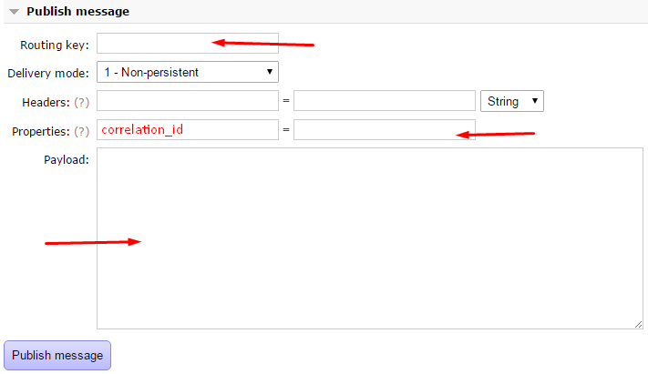Scroll down to the "Publish message" section, and fill in these things:

1. Routing key: paste in the routing_key field from Kibana.  
2. Properties: add a "correlation_id" property, and paste in the value of correlation_id from Kibana.  
3. Payload: This is where the XML goes (raw_message). But Kibana messes up the first tag in the XML; it adds some semicolons after every attribute. You have to remove them or it's not valid XML.

**Here's an example of what it's added that must be removed:**

**<ns2:provisionEnvironmentRequest xmlns:ns2="http://xmlns.fedex.com/CloudOps"; xmlns:ns3="http://xmlns.fedex.com/cds/cloud"; xmlns:ns4="http://xmlns.fedex.com/cloudops/event";xmlns:ns5="http://fedex.xmlns.com/cloudops/ticketing">;**

**Once you've got the XML cleaned up, click "Publish Message" and it will resubmit.**